**Literature Review Report**

**EXECUTIVE SUMMARY**

Introduction

AI-based localization and classification of skin disease with erythema. Although computer-aided diagnosis (CAD) is used to improve the quality of diagnosis in various medical fields such as mammography and colonography, it is not used in dermatology, where non-invasive screening tests are performed only with the naked eye, and avoidable inaccuracies may exist. This study shows that CAD may also be a viable option in dermatology by presenting a novel method to sequentially combine accurate segmentation and classification models. Given an image of the skin, we decompose the image to normalize and extract high-level features. Using a neural network-based segmentation model to create a segmented map of the image, we then cluster sections of abnormal skin and pass this information to a classification model. We classify each cluster into different common skin diseases using another neural network model. Our segmentation model achieves better performance compared to previous studies, and also achieves a near-perfect sensitivity score in unfavourable conditions. Our classification model is more accurate than a baseline model trained without segmentation, while also being able to classify multiple diseases within a single image. This improved performance may be sufficient to use CAD in the field of dermatology. Numerous systems have relied on image processing and feature extraction techniques to identify and forecast the type of disease. There are additional techniques created to recognize particular types of skin diseases using clinical characteristics and characteristics discovered by tissue analyses following a skin biopsy of the affected area. In commonly skin diseases are considered conditions and it is affected by our skin the main concepts of skin diseases may be considered as rashes, inflammation, and itchiness or the skin suffering.

Outline of Methodological Approach

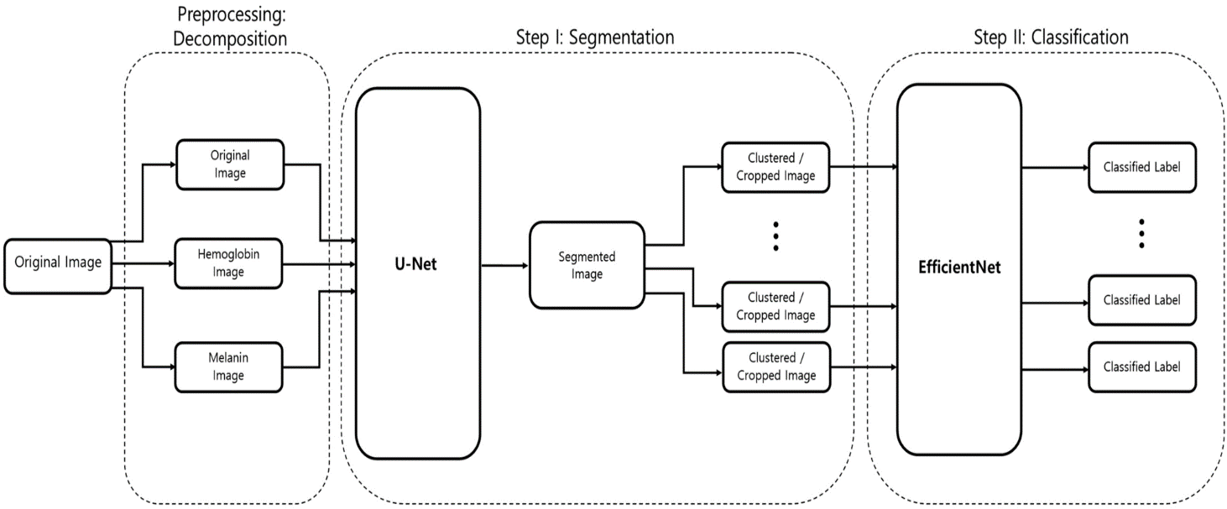

Identification, Selection and Analysis of the Literature

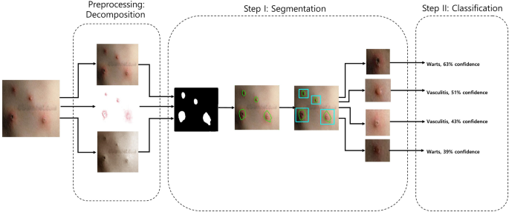

Findings

The result of this analysis gives that the enhanced results when compared to the existing technique. Verma et al. presented the Digital Diagnosis of Hand Foot and mouth disease using hybrid Deep Neural Network. Diagnosis and the datasets are classified by using the Mobile Net. **Reboucas Filho et al.** implemented the Automatic histologically–closer classification of skin lesions. Finally, it explains the accuracy classifications of the images. **Alsaade et al**. implemented the Developing a recognition system for diagnosing melanoma skin lesions using artificial intelligence. Deepa and Devi implemented the survey on artificial intelligence for medical image classification. Hameed et al. implemented an intelligent computer-aided scheme for classifying Multiple skin lesions, the skin diseases are classified by using the Computer-aided Diagnosis System (CAD). Hemanth et al. implemented the enhanced diabetic retinopathy detection and classification approach using a deep convolutional neural network. Chieregatoet et al. implemented the hybrid Machine learning/deep learning COVID-19 severity predictive model from CT images and clinical data this paper proposed the accuracy of the classifications. e 3100 Dermoscopy images collected from the PH2 and the ISIC datasets; except for the PH2 datasets, all the datasets are the resizing images, and it has different types of images, and the final results are based on the accuracy results in the form of the melanoma and the nonmelanoma skin diseases classifications.

**Conclusion and Future Work**

This paper implements that the Structural Co-Occurrence matrices for feature extraction in the skin diseases classification and the pre-processing techniques are handled by using the Median filter, this filter helps to remove the salt and pepper noise in the image processing; thus, it enhances the quality of the images, and normally, the skin diseases are considered as the risk factor in all over the world.

Our proposed approach provides 97% of the classification of the accuracy results while other existing model such as FFT + SCM gives 80%, SVM + SCM gives 83%, KNN + SCM gives 85%, and SCM + CNN gives 82%. Future work is dependent on the increased support vector machine’s accuracy in classifying skin illnesses, and SCM is used to manage the feature extraction technique.

**References**

[1] Arifin, S., Kibria, G., Firoze, A., Amini, A., & Yan, H. (2012) “Dermatological Disease Diagnosis Using Colour-Skin Images.” Xian: International Conference on Machine Learning and Cybernetics.

[2] Yasir, R., Rahman, A., & Ahmed, N. (2014) “Dermatological Disease Detection using Image Processing and Artificial Neural Network. “Dhaka: International Conference on Electrical and Computer Engineering.

[3] Santy, A., & Joseph, R. (2015) “Segmentation Methods for Computer Aided Melanoma Detection.” Global Conference on Communication Technologies.

[4] Zeljko Vic, V., Druzgalski, C., Bojic-Minic, S., Tameze, C., & Mayorga, P. (2015) “Supplemental Melanoma Diagnosis for Darker Skin Complexion Gradients.” Pan American Health Care Exchanges

[5] Suganya R. (2016) “An Automated Computer Aided Diagnosis of Skin Lesions Detection and Classification for Dermoscopy Images.” International Conference on Recent Trends in Information Technology